MX5 Vic&Tas logo(red)_OL

# **Buxton Big Burger Run**

Sunday, 15 June 2025 – 9.30am for 10am departure

This run starts at Beasley's Nursery & Tea House in Warrandyte.  
There’s a café (opens 8.30am) and toilets inside the nursery.

The run covers approximately 110km and will take about 2½ hours with two rest breaks.

This is NOT a fast run – enjoy the winding roads and the scenery.   
Drive to the conditions, and at your comfort level.

*Beware of cyclists, wildlife, debris on road, local traffic and slow drivers.*

***Starting point:* Carpark at Beasley’s Nursery –**195 Heidelberg-Warrandyte Rd, Warrandyte

***End point:* The Igloo Roadhouse, Buxton**

***Radio:* UHF channel 55 (note different channel!)**

***Run leader:* Murray – 0416 247 677**

**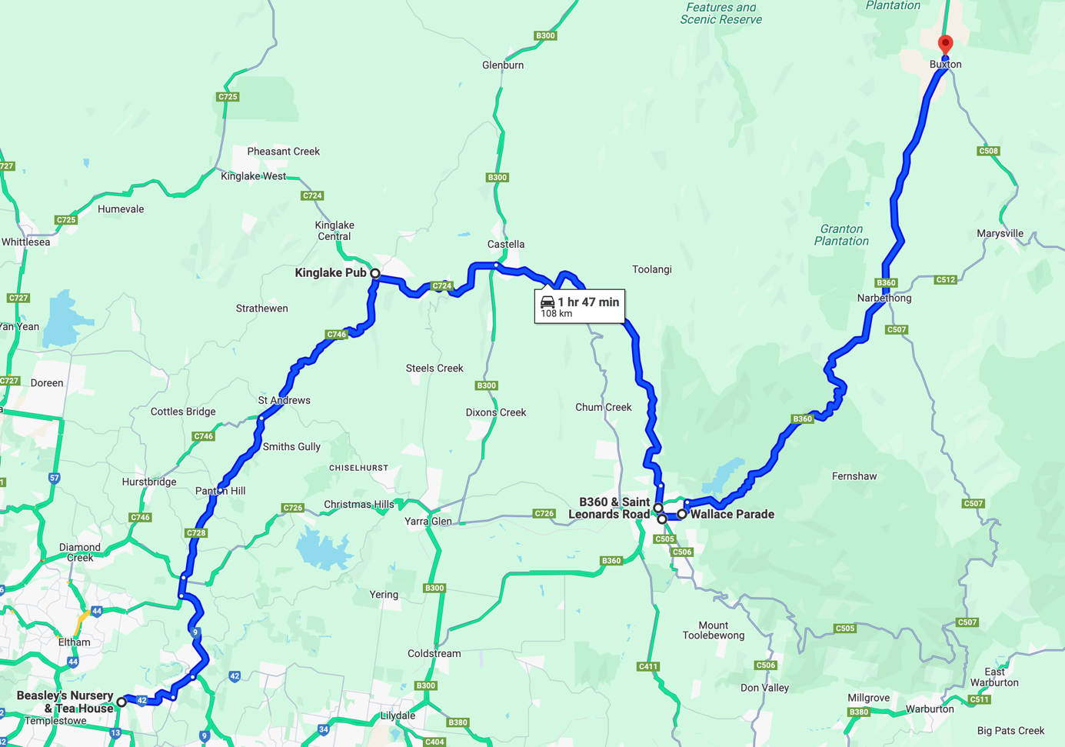**



***Regroup spot – carpark near Kinglake Pub***

***Rest spot***

***Queen’s Park, Healesville***



*…/2*

**Key:** SO - straight on • TL - turn left • TR - turn right • VL - veer left • VR - veer right

|  |  |  |  |
| --- | --- | --- | --- |
| ***Odo*** | ***Action*** | *Detail* | ***Travel*** |
| **Meeting point** | | **Carpark at Beasleys Nursery & Tea House** 195 Heidelberg-Warrandyte Rd, Warrandyte |  |
| **Re-set odometer as you leave the carpark. *[It’s approx. 40 minutes to regroup stop]*** | | | |
| 0.0 | TL | Exit carpark and TL on to Heidelberg-Warrandyte Rd [42] | 3.6 |
| 3.6 | SO | At the roundabout, take the first exit to stay on Yarra St [42] towards Warrandyte | 1.8 |
| 5.4 | TL | At the roundabout, TL towards Kangaroo Ground to cross the bridge. Head through the lights and up the hill (Kangaroo Ground-Warrandyte Rd [9], still towards Kangaroo Ground | 6.2 |
| 11.6 | TR | At the roundabout, take the third exit on to Eltham-Yarra Glen Rd [9], towards Kinglake. Continue SO towards Wattle Glen & Kinglake (road becomes Kangaroo Ground-St Andrews Rd [C728]) … ***do not TR*** *towards Yarra Glen [726]* | 1.1 |
| 12.7 | SO | Continue SO … ***do not TL*** *towards Wattle Glen [9]* | 5.8 |
|  | SO | At the roundabout outside St Mattews church, continue SO over Cross St towards Kinglake [C728] |
| 18.5 | VL | At the roundabout after passing Panton Hill primary school, take the first exit towards Kinglake [C728] | 5.1 |
| 23.6 | TR | At the bottom of the hill past the St Andrews Hotel, TR towards Kinglake [C746] | 13.0 |
| 36.6 | TL | At the roundabout, take the first exit on to Whittlesea-Kinglake Rd [C724] and head past the Kinglake shops | 0.2 |
| 36.8 | TR/TL | Into Kinglake-Glenburn Rd, and them immediately TL into the carpark to the right of the Kinglake Pub | 0.1 |
| **Leg-stretch / toilet stop – approx. 15 minutes** | | | |

|  |  |  |  |
| --- | --- | --- | --- |
| **Part 2 – approx. 30 minutes** | | | |
|  | | | |
| ***Odo*** | ***Action*** | *Detail* | ***Travel*** |
| **Re-set odometer as you exit the carpark** | | | |
| 0.0 | TL/TR | Out of the carpark, then TR into the main road and head back past the Kinglake shops to the roundabout. | 0.3 |
| 0.3 | TL | At the roundabout, take the second exit on to Healesville-Kinglake Rd [C724], towards Healesville | 9.1 |
| 9.4 | TL/TR | Quick left then right across Melba Hwy to continue on Healesville-Kinglake Rd [C724], towards Toolangi/Healesville | 7.5 |

**Key:** SO - straight on • TL - turn left • TR - turn right • VL - veer left • VR - veer right

|  |  |  |  |
| --- | --- | --- | --- |
| ***Odo*** | ***Action*** | *Detail* | ***Travel*** |
| 16.9 | TL | On to Myers Creek Rd | 14.4 |
|  | --- | Continue along Myers Creek Rd towards Healesville.  *(When the road straightens out at the bottom, it becomes  St Leonards Rd.)* |  |
| 31.3 | TR/TL | At the traffic lights, TR into Maroondah Hwy then immediately TL into Don Rd [C506] *(****Note:*** *may take a couple of light changes to get all cars through.)* | 0.7 |
| 31.7 | TR | Into Queens Park | 0.1 |
|  | TR | At the oval, follow the road around to the right, then TR and keep following the road. Park where you can; toilets are on the right. | 0.3 |
| **Leg-stretch / toilet stop – approx. 20 minutes** | | |  |

|  |  |  |  |
| --- | --- | --- | --- |
| **Part 3 – approx. 35 minutes** | | | |
|  | | | |
| ***Odo*** | ***Action*** | *Detail* | ***Travel*** |
|  | --- | Head back out the way you came, towards Don Rd |  |
| **Re-set odometer at Don Rd as you exit Queens Park** | | | |
| 0.0 | TL | Into Don Rd [C506] | 0.7 |
| 0.7 | TR | At the traffic lights, TR on to Maroondah Hwy [B360], towards Black Spur & Narbethong. *(****Again,*** *may take a couple of light changes to get all cars through.*  ***If needed, regroup*** *on the left of Maroondah Hwy just after the turn at the lights.)* | 38.5 |
| --- | | Follow this road all the way to Buxton.  *DO NOT turn right to Marysville.* | |
| 39.2 | --- | At Buxton, we’re heading for the *Igloo Roadhouse*.  It’s on the right, around the middle of the town, just after the pub. | |
| *Park where you can – in the roadhouse car park to the right of the bowsers, along the left-hand fence or out the back ... or on the highway itself … and head inside.* | | | |